NEPA Mixed Martial Arts, LLC.

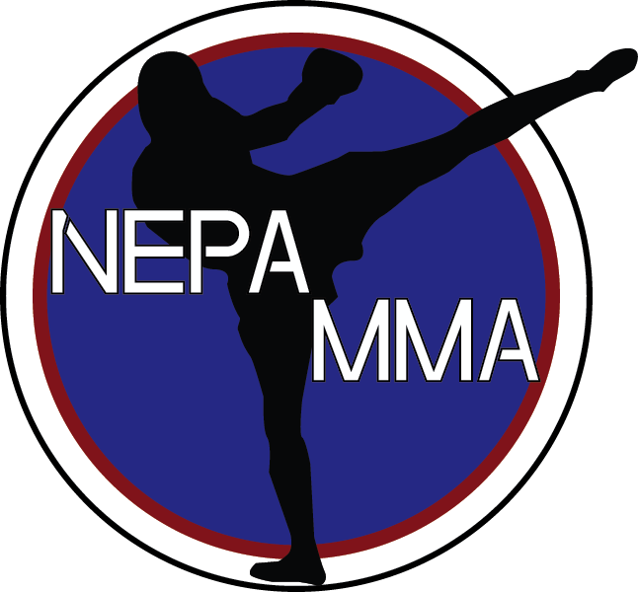

RELEASE AND WAIVER OF LIABILITY AND INDEMNITY AGREEMENT

READ CAREFULLY AND SIGN BELOW

IN CONSIDERATION of being accepted as a student of NEPA MMA, LLC located at 213 east Luzerne Ave Larksville, Pa 18704 Students Name(s)__________________________.

1. UNDERSTAND that Martial Arts is a physical activity and involves a risk of injury. I also
understand that martial arts is a contact sport and that my training will involve physical contact
between myself and other students or instructors including but not limited to, punching, kicking,
throwing, grappling, and weapons. With this knowledge, I assume the full risk of and
responsibility for any bodily injury, death, or property damage due to the negligence of NEPA MMA, LLC arising from or related to my conduct and activities while on NEPA MMA, LLC premises, for my conduct and activities as a student of NEPA MMA, LLC, or the conduct and activities of other students or instructors of NEPA MMA, LLC.

2. HEREBY RELEASE, WAIVE, DISCHARGE, AND COVENANT NOT TO SUE NEPA MMA, LLC Instructors, students of NEPA MMA, LLC, members, owners, partners, or
principals of of NEPA MMA, LLC, and each of them, from all liability for any and all claims
or demands arising from or related to any injury to the undersigned or my personal property on
account of the undersigned, whether caused by the negligence of NEPA MMA, LLC, any of its instructors, students, members, owners, partners, principals or owners of lessors of NEPA MMA, LLC including the partial or sole negligence of any of them.

3. AGREE TO INDEMNIFY, defend, and hold harmless NEPA MMA, LLC, owners, officers, and principals, and each of them, from any loss, liability, damage, cost, action, or lawsuit, arising from or related to my conduct and activities while on NEPA MMA, LLC premises or from my conduct and activities as a student of NEPA MMA, LLC.

4. EXPRESSLY AGREE that the foregoing release, waiver, and indemnity agreement is intended to be as a broad and inclusive as is permitted by the state of Pennsylvania and that if any portion thereof is held invalid, it is agreed that the balance shall, notwithstanding, continue in full force and legal effect. I have read this Release and Waiver of all Liability, and Indemnity Agreement and voluntarily agree to each of the provisions and terms thereof. I further agree that there have been no oral representations, statements, or inducements made apart from the foregoing written agreement. All persons under eighteen (18) years of age must have written consent of their own parent (s) or legal guardian to participate.

Date: _________________________________ Name and Signature of Parent/Guardian
Print Name: ____________________________ Name: ____________________________
Signature: _____________________________ Signature: _______________________
Phone Number: _________________________
Address: _____________________City: __________________ State: _____
Zip-Code: _______________ Email Address: _______________________________
NEPA MMA
NEPA Mixed Martial Arts
Guest Inquiry

Date _____________

Name: __________________________ Age: ____ D.O.B______
Parent’s Name: ___________________ Phone: _______________
Address: ____________________________ City: _____________
Zip-Code: __________ State: ______ Email: _________________
Interested in Enrollment? Yes_____ No_____

In order to determine how the instruction at NEPA MMA can better adequately meet and serve your needs please check one or more of the following:

___ Physical Conditioning
___ Better Concentration
___ Inner Peace
___ Weight Control
___ More Energy
___ Self- discipline
___Athletic Skill
___ Better Mental Attitude
___Temper Control
___Better Grades
___ Respect for Self & Others
___ Others: ______________

Now… Circle the single most IMPORTANT benefit for you.

Is there anyone else you would like to refer?

Name: ______________________ Phone Number: ____________________
Interested in Enrollment? Yes_____ No_____

